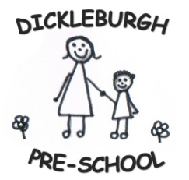

The Role of Parents
At Dicklebugh Pre-School we have an open door policy at all times. We regard our partnership with parents as vital in making a difference to each child’s life. We depend on the goodwill, support and commitment from parents, and we will fulfil parents expectations of us by making you feel:
! Valued and respected
! Informed
! Consulted
! Involved
! Included at all levels
How Parents take part in the Setting
The Pre-School team recognises that working in partnership with parents is a very valuable and important part of this setting. This enables us to provide a happy, safe and loving environment where children are able to reach their full potential in all areas of development. We aim to form a good relationship with parents and families so that information regarding their child can be exchanged easily and comfortably between members of staff and parents.
Our Pre-School recognises parents first as the most important educators of their children. There are many ways in which parents take part in making our setting a welcoming and stimulating place for children and parents, such as:
! Exchanging knowledge about their children’s needs, activities, interests and progress with the team,
! Sharing their own special interests with the children in our setting,
! Helping to provide, make and look after equipment and materials used in the children’s activities,
! Take part in events and informal discussions about activities and curriculum provided by our setting,
! Joining in community activities in which our setting takes part
! Joining our friendly committee who meet once every half term
The Parents Rota
Our setting has a rota which parents can sign if they would like to participate in a particular session at Pre-School. Helping at a session enables parents to see what day to day life in our setting is like and to join in helping the children to get the best out of their activities. It is also a good opportunity to chat with your child’s Key Person about their development, and see for yourself what your child enjoys and Pre-School and who they play with.

